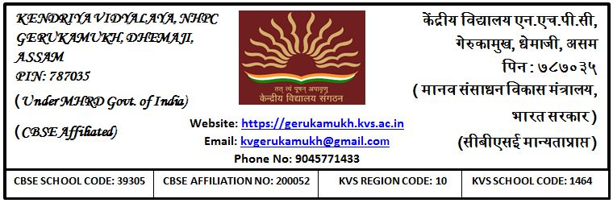
Q-la- 1464/la-fu-/dsfoth/,u,pihlh/2023-24/ fnukad: 24.08.2023

WALK In INTERVIEW
Date- 28/08/2023(Monday)

A walk in Interview is to be conducted on 28/08/2023 in Kendriya Vidyalaya NHPC, Gerukamukh, Dist- Dhemaji, ASSAM on purely contractual basis for the session 2023-24. The candidate between age 18 to 65 years may report to the vidyalaya with their required documents (educational, experience certificate, PAN card, Adhar card, etc) in original and Xerox (photocopy) without fail on 28/08/2023 at 09. 00 am. No TA/DA will be provided for the candidates appearing for the walk in Interview.

